VNC1L-1A Programming

VNC1L-1A programming can be done by different methods as suggested by manufacturer. FTDI method was used in this project. It needs five wires and programmer software.

Programming VNCL1 using the ROM file needs patience since it may take one or two attempt to complete it. VNC1L-1A programmer board and circuit are available with author.

The VNC1L-1A has two USB ports and a combined serial UART, Serial Peripheral Interface (SPI) or FIFO interface. Pins USB1DP and USB1DM carry USB data signals D+ and D- of USB Port-1. Pins USB2DP and USB2DM carry USB data signals D+ and D- of USB Port-2. Port-1 supports USB slave peripherals(not used). Port-2 supports BOMS (Bulk Only Mass Storage) Class devices such as USB flash drives.

Circuit and working

Circuit diagram for VNC1L-1A Programmer is shown in Fig. 1.It is built around 3.3V voltage regulator MAX232(IC1), MCU VNC1L-1A MUC (IC2), FT232RL (IC3) and and few other components.

To begin with, the updated VDAP firmware version, DAPFUL_V3_69.ROM is downloaded in the flash memory of VNC1L-1A. It is downloaded from a PC via USB using a USB to RS232 converter IC FT232RL and a ROM programmer tool ‘VPROG’.

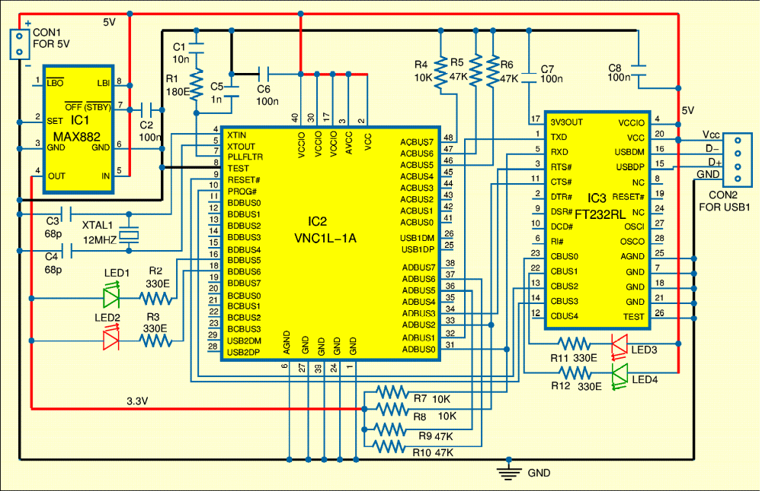

Fig. 1: Circuit diagram of VNC1L-1A Programmer
FT232RL enables the USB port in a PC to be used as a virtual COM port. It requires a driver provided by FTDI to be installed in the PC so that it can then communicate with the VNC1L-1A through the UART interface. The UART interface is selected for communication by connecting ACBUS5 (pin 46) and ACBUS6 (pin 47) of VNC1L-1A to the ground via 47kΩ. While programming, the PROG# (pin10), RESET# (pin 9) pins of VNC1L-1A are connected to CBUS2 (pin 13), CBUS3 (pin 14) pins of FT232RL respectively. The CBUS2 and CBUS3 pins are configured as I/O pins using the utility program ‘MProg3.0a’.The steps to program VNC1L-1A using MProg3.0a and ‘VPROG’ VNC1L-1A flash programmer are as follows.
1.Install FTDI driver for USB to RS232 converter.
2.Open MProg3.0a and go to the tools option from the pull down menu select execute Read and Parse command. The present status of I/O pins will be displayed. Configure CBUS2 and CBUS3 pins as I/O pins , save the template and program the device using Prog option.
1.'VPROG’ VNC1L-1A flash programmer is used to fuse the firmware VDAPFUL_V3_69.ROM into VNC1L-1A flash memory.

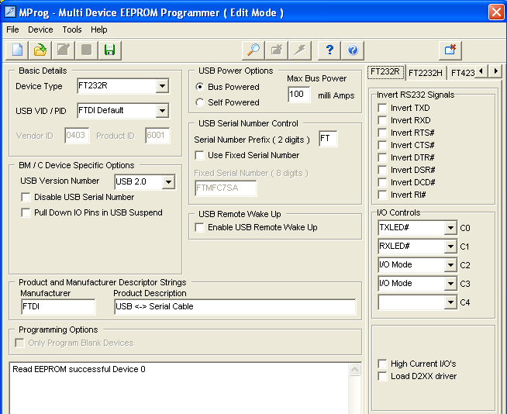
Fig. 2: MProg Software to modify I/O controls
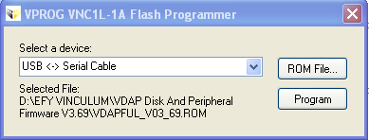
Fig. 3:VPROG VNCL-1A Flash Programmer
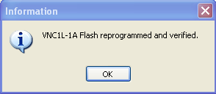
Fig 4:VPROG VNCL-1A Flash Programmer
Construction and testing
An actual-size, single-side PCB for VNCL-1A Flash Programmer is shown in Fig. 5 and its component layout in Fig. 6. Assemble the circuit on the circuit on PCB. Connect secondary of 5VDC across CON1 for driving the circuit.

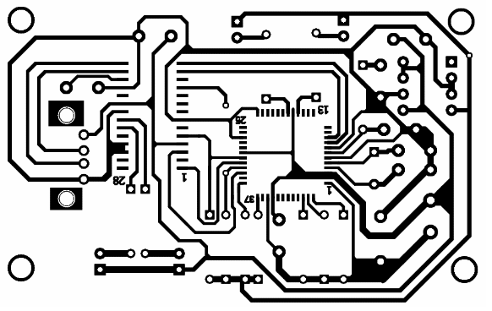

Fig. 5: Actual-size single side PCB for VNCL-1A Flash Programmer

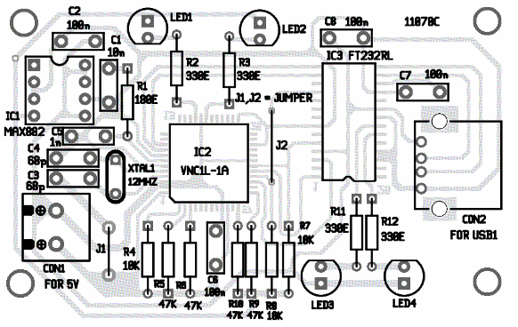

Fig. 3: Components layout of the PCB.

EFY Note: Programming VNCL1 using the ROM file needs patience since it may take one or two attempt to complete it.

